WEB TECHNOLOGIES

**Name:** Muhammad Saim Ashfaq

**REG#:** SP18-BCS-115

**Dated:** 20-01-2021

**SUBMITTED TO:**

SIr AKHZAR NAZIR

Semester Project

Car Rental App

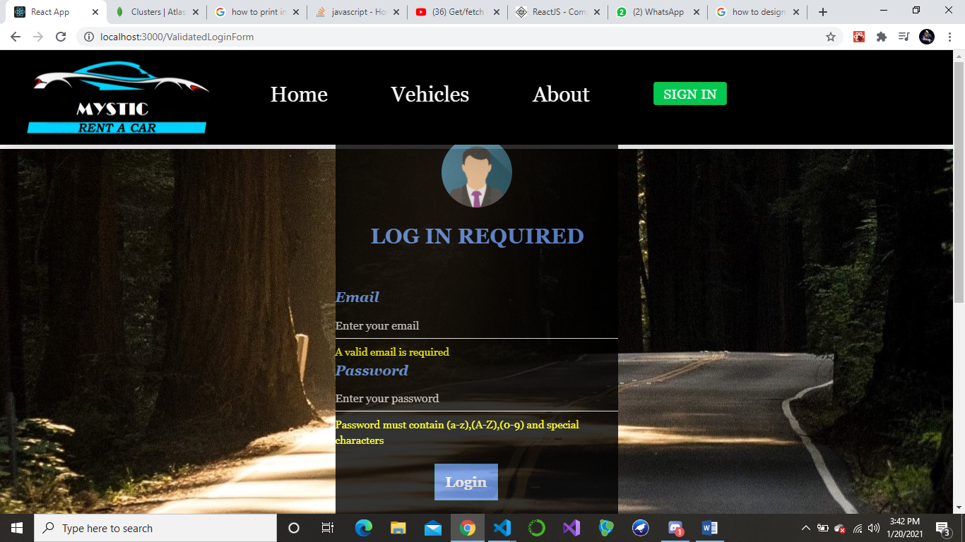**LOGIN PAGE:**

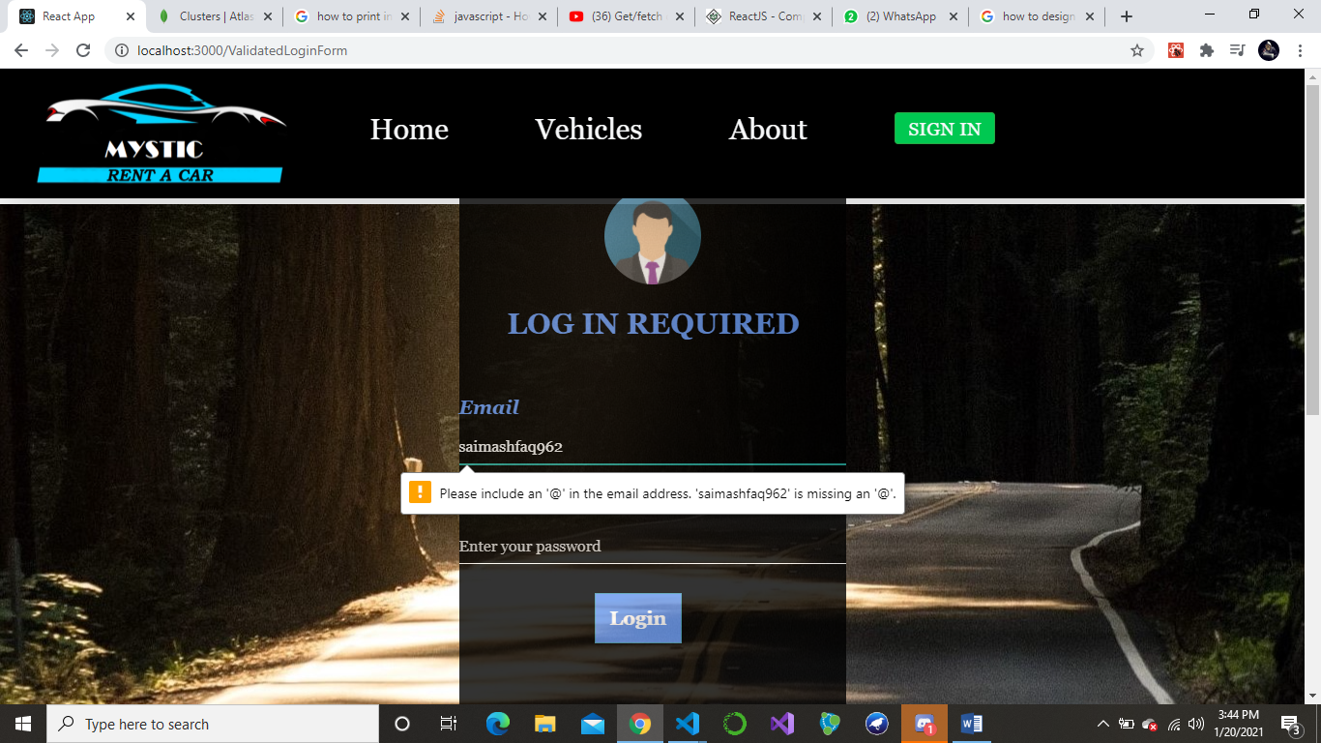

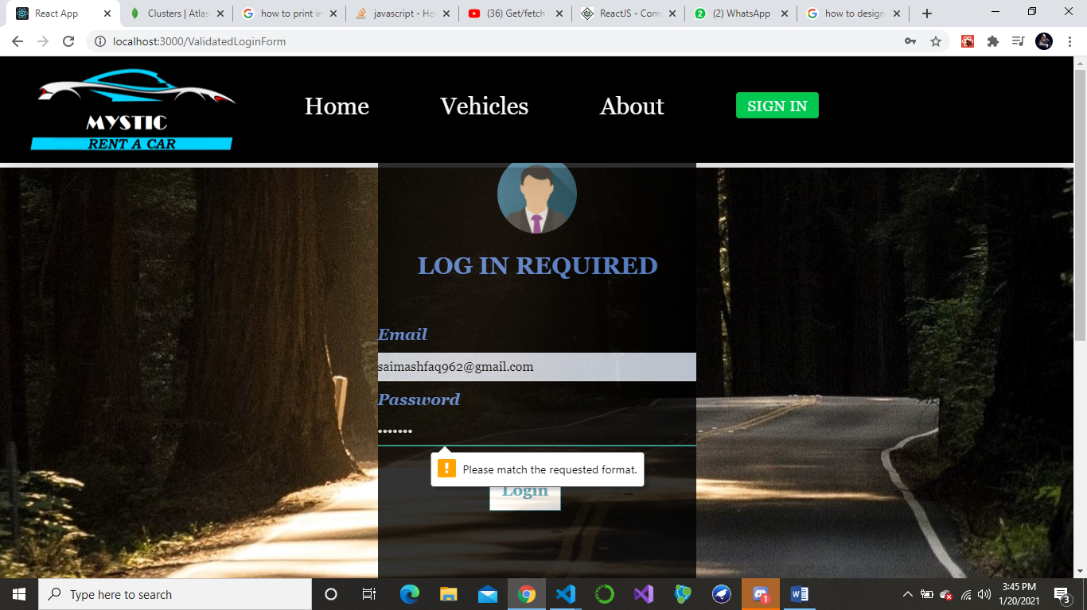

I have done simple validation on email and password in login form in the above format. I am not comparing it with some email and password because I am just using it for new user who want to book a Car. Booking Page is enabled only when the user is logged in.

**HOME PAGE:**

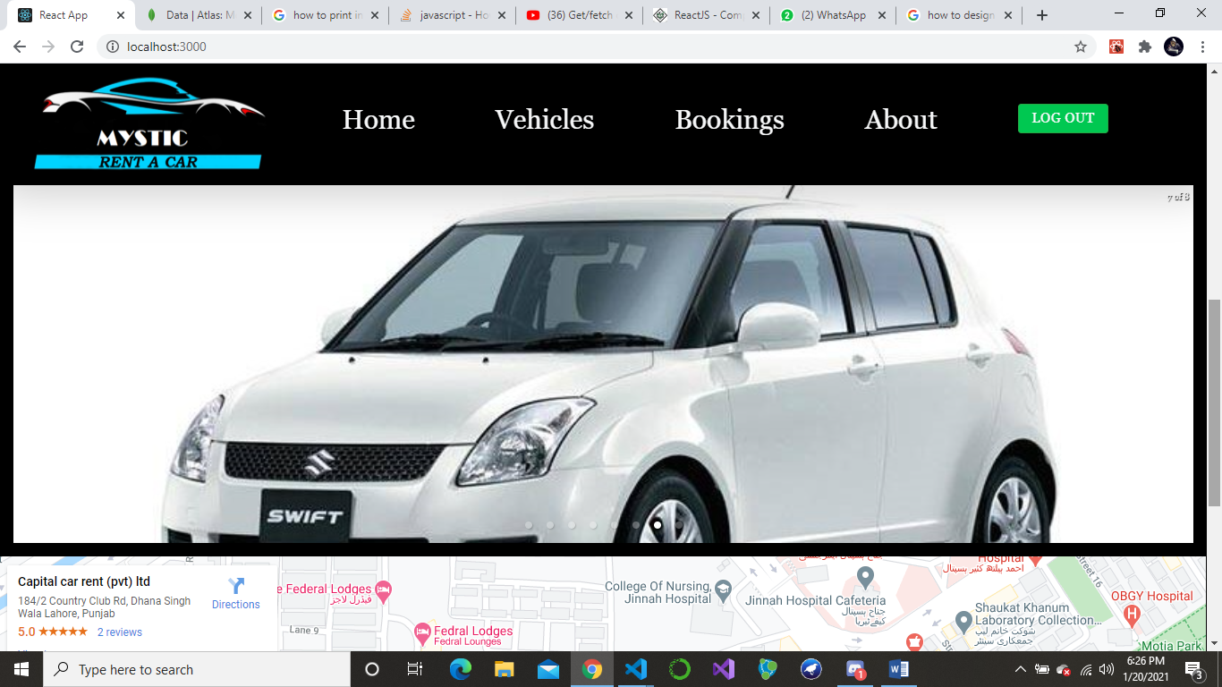On home page, I have shown pictures of Cars (Through Carousel) which we have and a Map to the location where the user would Pick up the car if he wants to collect it on his own.

**VEHICLES PAGE:**

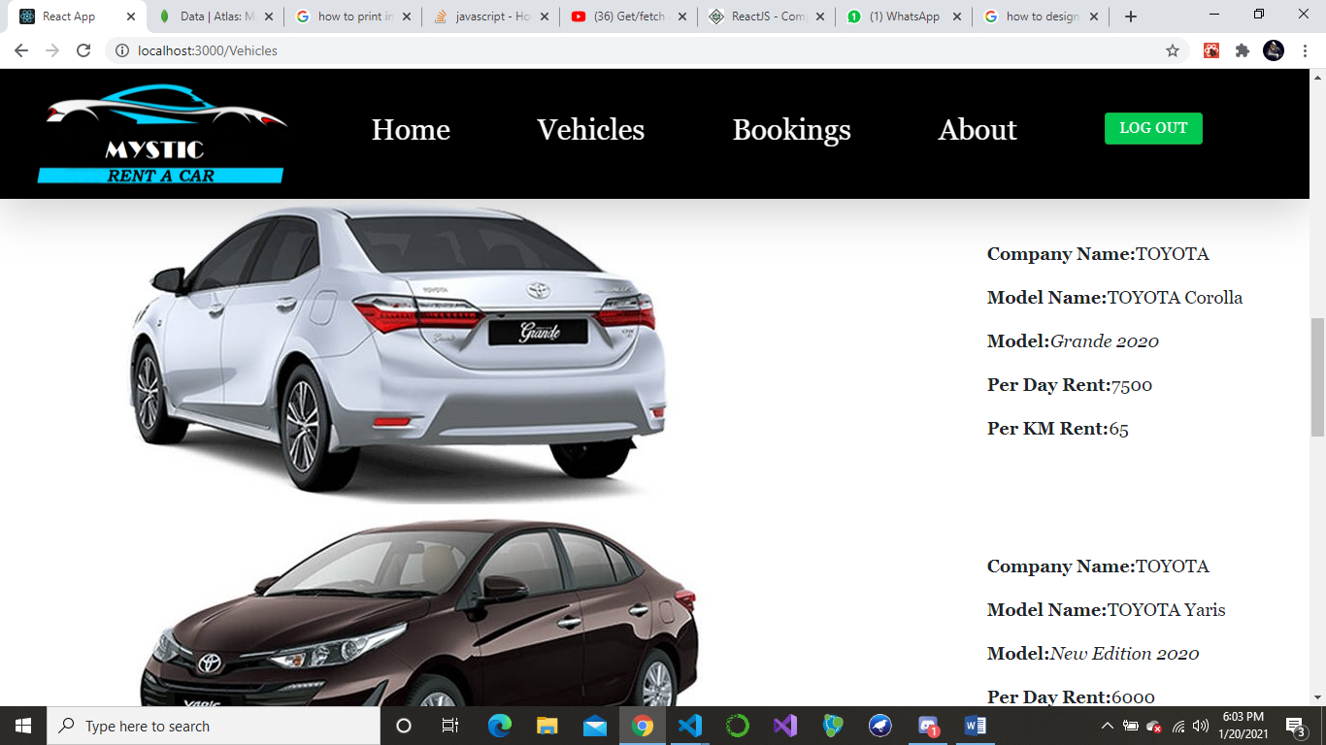

In vehicles page, I am just showing the information about specific car models. Price, company and model name etc.

**ABOUT PAGE:**

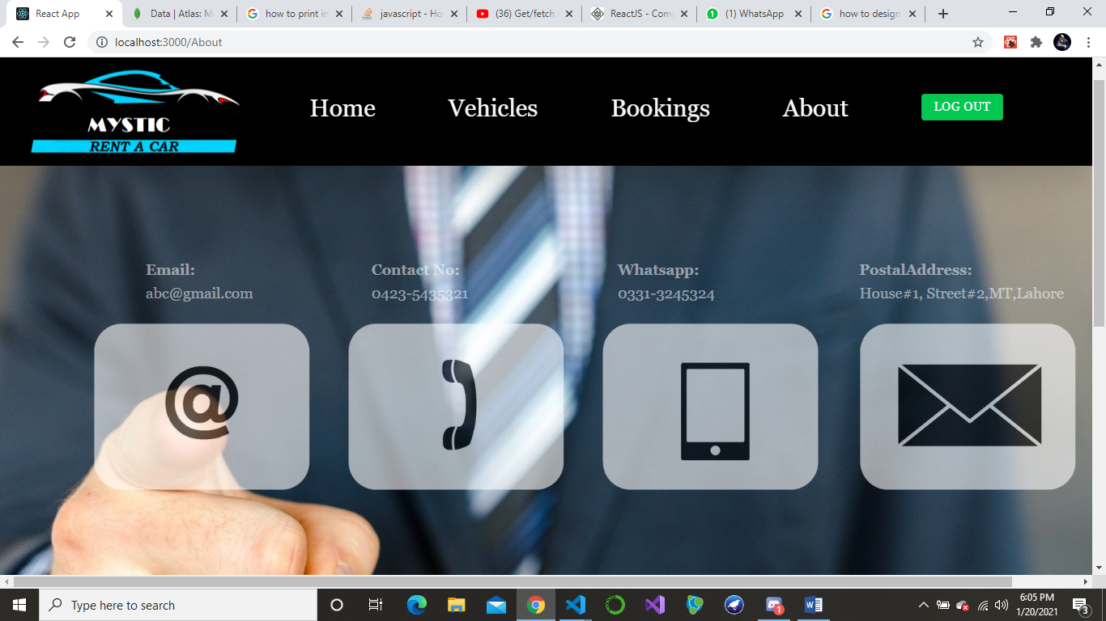Contact info is given in the about page.

At the top, I have added logout button which disables the booking page if the user logs out.

**BOOKING PAGE (Main Module):**

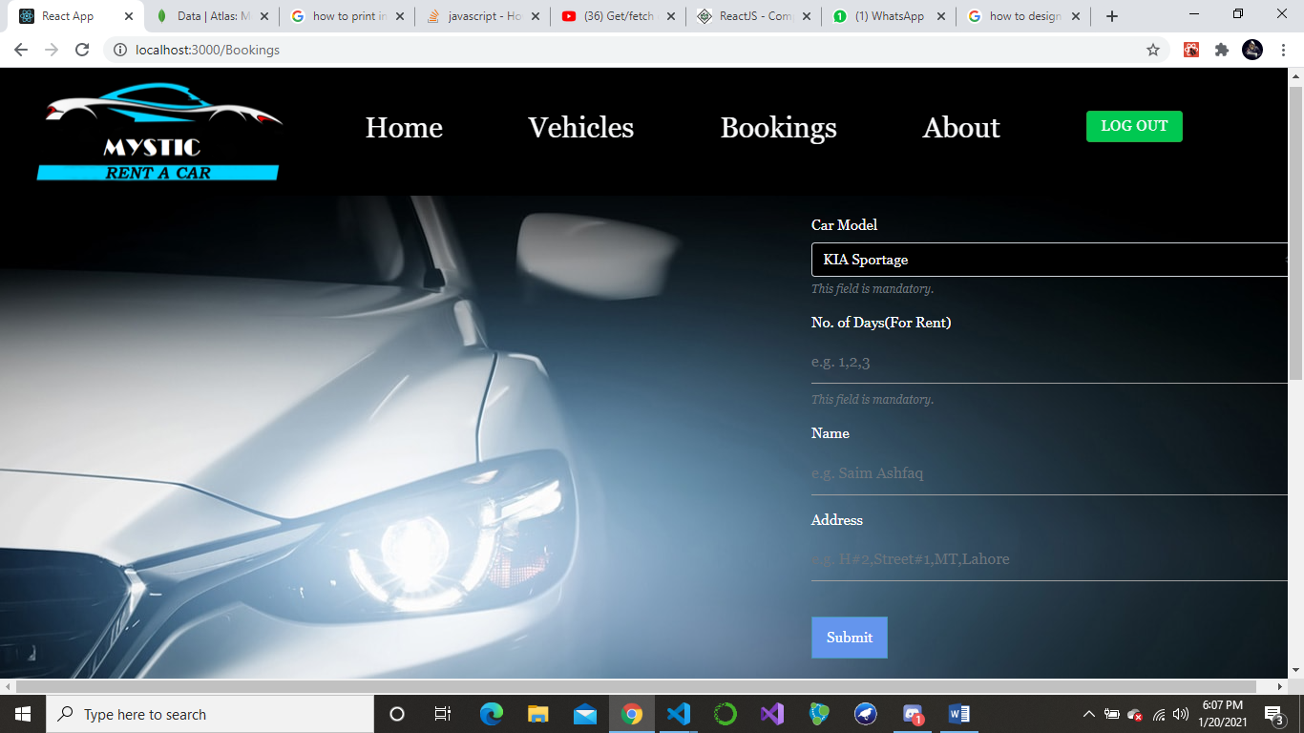

Main module in the website is that Booking Page where user can book a Car.

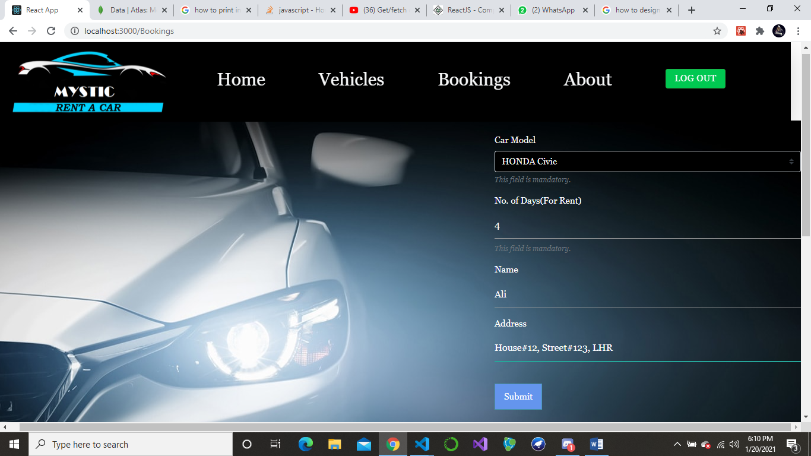

After user input data in the form and Submit it. He will be shown with an additional button which will give him the option to view Receipt.

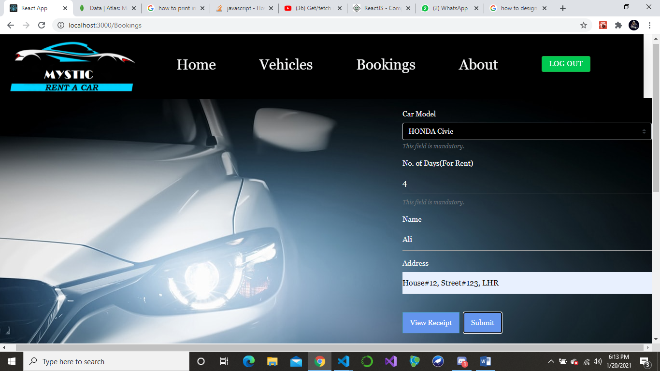

If we enter the View Receipt button we will be shown with a Receipt type thing which will Show order Info. i.e. Car Name which he has ordered, no. of days he’s renting it for and the Total bill.

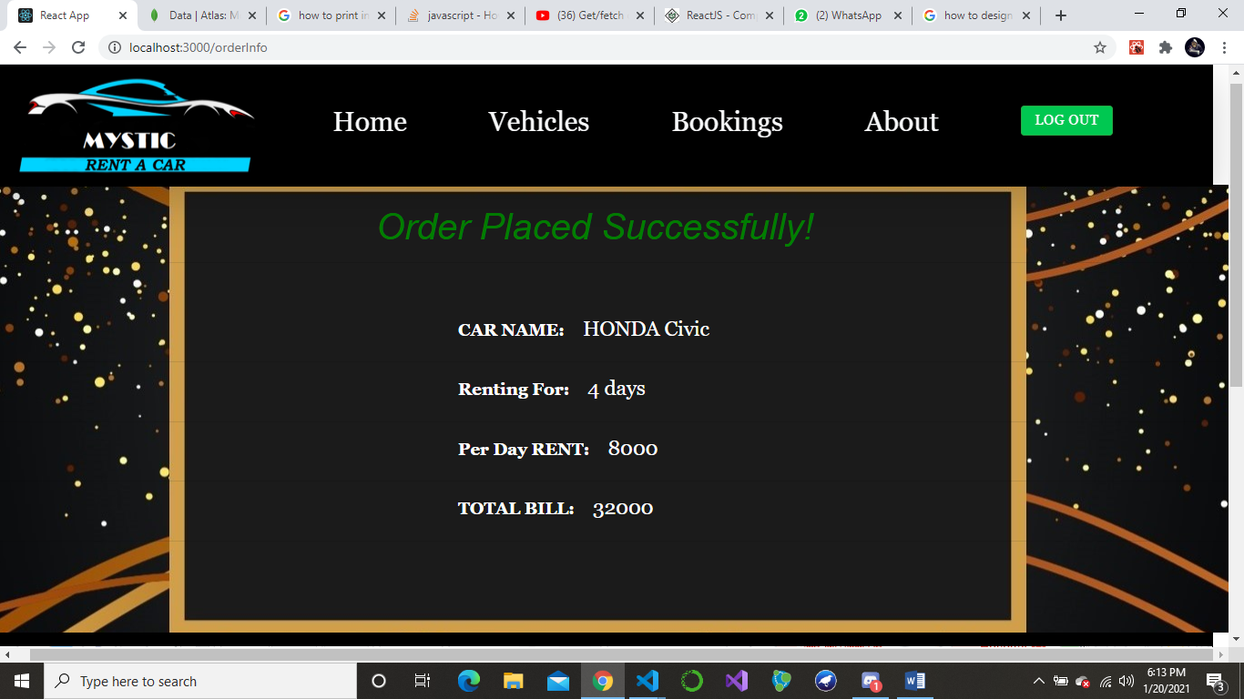

One more thing which I am handling is that if the user Selects the Car which is already booked before like HONDA Civic in this case. It will show an alert on the browser that “Car is already booked”.

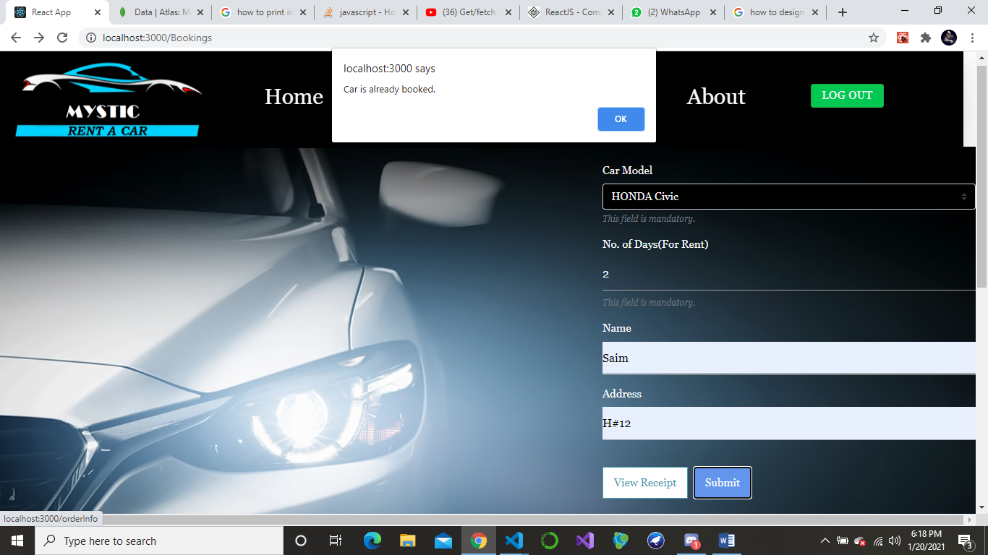

**TO BE NOTED:**

One thing I want to clear is that I haven’t built an Admin login through which products Data will be wrote in the Database. So I have built a Schema and .get and .post method for Products but haven’t sent it in type of forms as I am not managing Admin Panel. Rather, I have passed products information through postman and have wrote Hard Coded information about Cars in the Database. So, in case of Testing, first you have to write some Product Data in the Database then the website will be in the working condition because First we check Product Data in the database if the product is present then the Order proceeds.

**SCREENSHOT OF WRITING PRODUCT DATA: (Via POSTMAN)**

